Steps to setup Wave tool Scraper.

1. We need python to run this project. If already installed then no problem if not installed then please do follow below steps to install python on your machine.
   1. Go to the link : <https://www.python.org/downloads/>
   2. Download latest version of python
   3. And then install the python on your machine
   4. Now lets check if it is properly installed in your machine.
   5. Open cmd and type “python” and press enter.

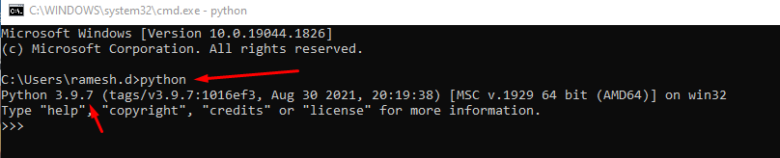

* 1. You should be able to see the python version, then you have successfully installed.
  2. If you get any error then it means python is not set in the environment variable, then follow this video to get it resolved <https://www.youtube.com/watch?v=Y2q_b4ugPWk>

1. Install wkhtmltopdf 64-bit on Windows - https://wkhtmltopdf.org/downloads.html
2. We also need mysql for this project. If already installed, then skip the mysql installation steps
   1. We can install xampp for windows or mysql workbench
   2. Go to the link: <https://www.apachefriends.org/download.html>
   3. Download the respective xampp version and proceed with installation.
3. Copy the project to your local system. Assume you have copied the project to D: drive
4. Now open cmd using Run as administrator.

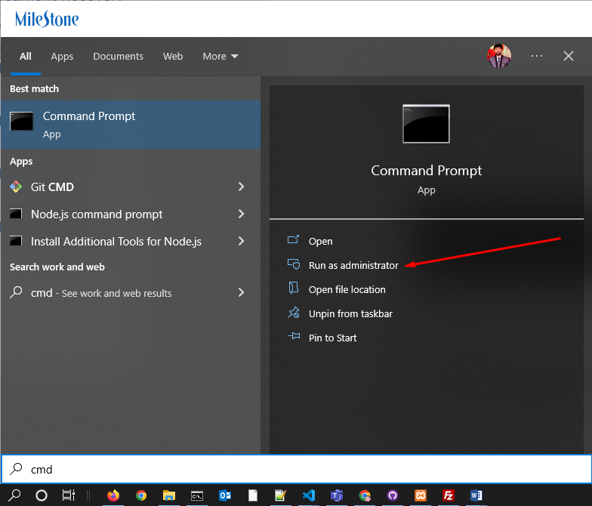

1. Now in cmd type go to your project directory.
2. In cmd type
   1. D:
   2. cd ProjectFolderName
3. Now lets create virtual environment for the project
4. In cmd type
   1. pip install virtualenv
   2. virtualenv venvWave
   3. cd venvWave/Source
   4. activate
5. Now you can see you have activated the virtual environment

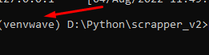

1. Now go back to main project folder root directory
   1. In cmd type
   2. cd ..
   3. cd ..
2. This will bring you back to project folder root location
3. Now lets install requirements.txt file present in your directory.
4. In CMD type
   1. pip install –r requirements.txt
5. It will start installing all the necessary packages.
6. Now lets setup database
7. Open Xampp -> Start Apache & MySQL server

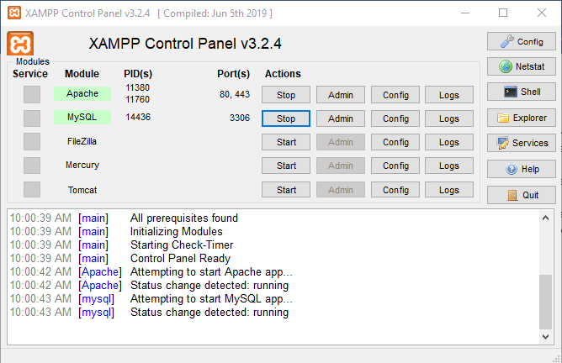

1. Once started and look green then for MySQL click Amin button. It will open browser and the MySQL database.
2. Click on Import

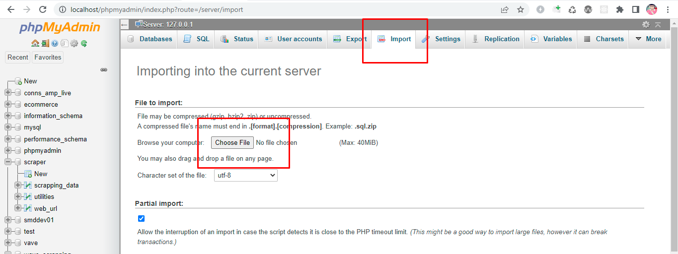

1. Choose & Upload the Database scraper.sql file from the project folder.
2. In cmd type python main_file.py

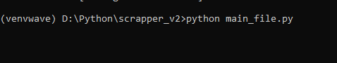

1. It will start python Application

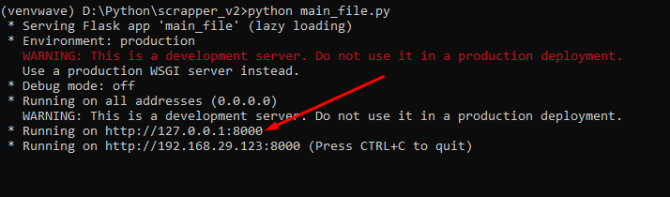

1. In browser open the above link <http://127.0.0.1:8000/>

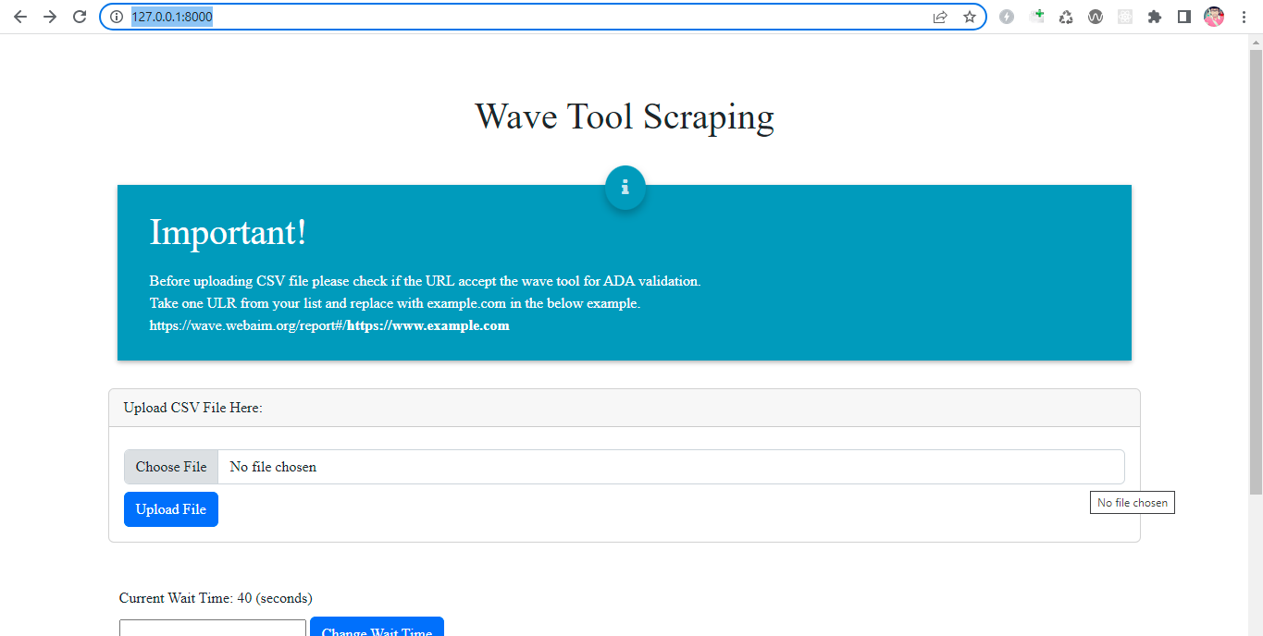

1. Please upload CSV file only having only one URL list with not heading. Like below example.

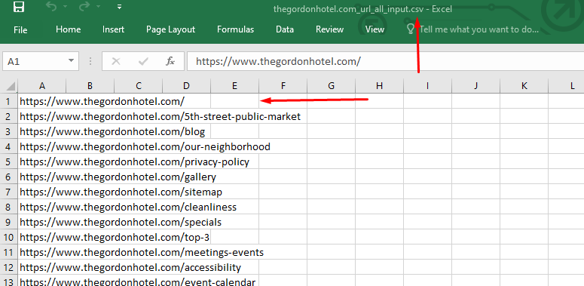

1. Now make sure the urls will accept wave tool to generate error report. We can check by running one sample url

[https://wave.webaim.org/report#/**https://www.example.com**](https://wave.webaim.org/report#/https://www.example.com)

replace <https://www.example.com> with one of your URL and check the url in browsers if we get the data.

If you don’t get error count and website keeps loading, then this URLs will not work so don’t run the scraper.

If you get the error counts, then run the scraper.

1. You can set sleep time, by default it is set 40 seconds. This is nothing but the program will wait for 40 seconds so that the url is completely loaded before scraping begins for each URL else blank data will be scraped like “?”
2. Click Generate Report button to start the scraping.
3. After Scraping is complete download the csv and check if all data is proper. If you find any URL with data as “?” then increase the sleep time and click the failed orange button. This will run only the failed URLs again. And then download the final report.

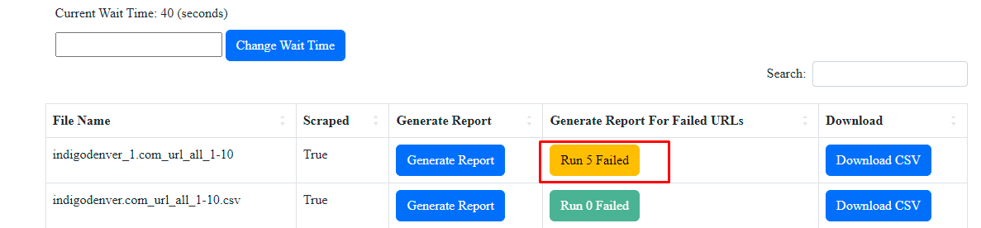

Regular steps:

1)Turn on the MySql server using Xampp.

2)Open cmd using Run as administrator.

3)Go to your project directory. In cmd type

a. D:

b. cd ProjectFolderName

4) In cmd type

a. cd venvWave/Source

b. activate

5) Now go back to main project folder root directory

In cmd type

a. cd ..

b. cd ..

6) This will bring you back to project folder root location

7) In cmd type python main_file.py